**Customer Lifetime Value**

**Wireframe Documentation**

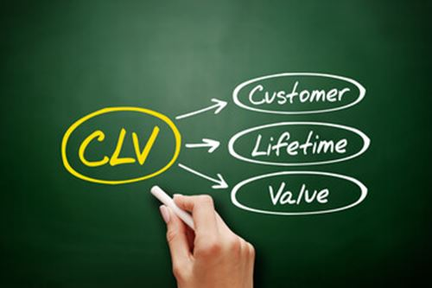

**Project On:**

**Title : Customer Lifetime Value**

**By: Rushikesh Khandare**

Homepage:

As per the problem statement we have created a single dashboard.

Final Dashboard:

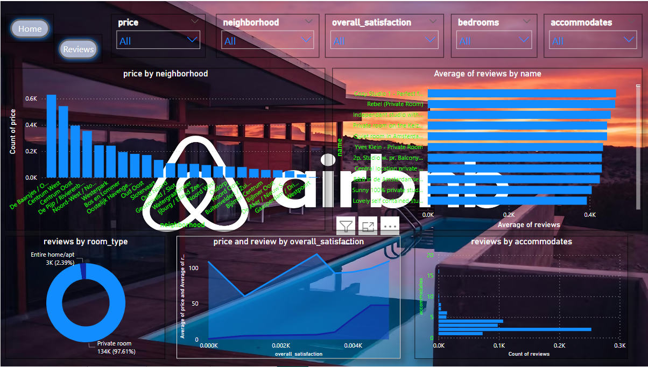

NovyPro Link :- *https://project.novypro.com/7lIopO*

Github Link :-  *https://github.com/Rushi9867/Airbnb-Data-Analysis*